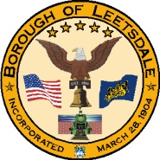

Borough of Leetsdale

Incorporated 1904

Municipal Liens ($25.00 Fee):
Borough of Leetsdale
373 Beaver Street, Suite A
Leetsdale, PA 15056
724-266-4820

Occupancy Permit ($45.00 Fee payable to the Borough):
Code Enforcement Officer
Building Inspection Underwriters of PA, Inc.
Submit request and payment to the Borough Office
412-766-2565

Water or Sewer Liens:
Edgeworth Water Authority
313 Beaver Road
Sewickley, PA 15143
412-741-5100

For Property Tax Information ($25.00 Fee):
Thomas Belcastro
400 Industrial Drive
Leetsdale, PA 15056
Office: 724-318-8376
Cell: 412-660-8556

Please be advised that Leetsdale Borough Council adopted Ordinance 593 on January 12, 2006. This ordinance requires annual inspections of rental properties in the Borough of Leetsdale. If this property is a rental property, please contact the Borough Office at the address, phone number or email address below for a license application and further information.

